

Personal Finance Mobile Widgets User Guide

A Guide for New Users

Updated March, 2018

# 

**Contents**

Getting Started 4

1. Link your external accounts. 4

2. Review your transaction history. 4

3. Set up a budget. 5

4. Stay in the loop. 5

Accounts 6

Adding an account 6

Fixing connection errors 7

Manual account 8

Account details 9

Editing an account 10

Marking an account as closed 11

Hiding an account 12

Merging an account 13

Managing account notifications 13

Transactions 15

Categorizing your transactions 15

Uncategorized transactions 16

Editing, splitting, tagging, flagging, and more 16

Splitting transactions 17

Adding a manual transaction 18

Pending transactions 19

Deleting and excluding transactions 19

Search, sort, and filter transactions 20

Spending 22

Budgets 24

Auto-generating budgets 24

Starting from scratch 25

Recalculating budgets 25

Using bubble budgets 25

Editing budgets 26

Projected income 27

Adding and deleting budgets 28

Goals 30

Savings goals 31

Debt payoff goals 32

Retirement goal 32

Managing goal contributions and priorities 33

Net Worth 36

Cash Flow 38

Filtering by account 39

Editing cash events 39

Adding a cash event 40

Marking as paid 41

Deleting a Cash Event 41

Settings 42

Profile 42

Mobile devices 43

Notifications 43

# 

# 

# 

# Getting Started

At FIS, we think banking should be easy, helpful, and empowering. We think this software will help you better understand and manage your finances so you can spend less time worrying about money — and more time enjoying the security and comfort it affords you.

When you first use the software, you may be prompted to accept our Terms and Conditions.

If you are accessing the software through a financial institution, the accounts you have with that provider will be imported automatically. We recommend you do the following things first.

### Link your external accounts.

Add accounts from other institutions so you can view your whole financial picture in one place. Nearly any financial account can be linked — checking and savings accounts, credit cards, loans, mortgages, and other lines of credit. You can also easily track cash or property values by adding manual accounts.

*ℹ️ — Property accounts are important in Net Worth for tracking high-value assets such as your home or vehicles.*

### Review your transaction history.

Transactions will be automatically adjusted for readability, then categorized to make it easy to see where your money is going. Not all transactions can be automatically categorized, so it’s important to review your transactions regularly. For example, checks and ATM withdrawals will be labeled “Uncategorized,” and you will be prompted to assign a category to such transactions. Make any changes necessary to ensure your spending data is complete and accurate.

It can be helpful to review your spending chart after reviewing your transactions. You will better understand how your transaction categories influence your financial reports, and reviewing your spending can often reveal spending details that need to be recategorized.

### Set up a budget.

A budget makes it easy to visualize how much you’ve spent and how much money you have left. Select “Auto Generate Budget” to let Personal Finance calculate your average monthly spending in each category for the last two months with complete data. This gives you a realistic starting point for your budget.

*ℹ️ — An auto-generated budget will be more helpful if you first add any outside accounts and review your transactions so that your budget calculations are based on a full and complete spending history.*

### Stay in the loop.

Notifications can keep you notified of important things happening with your accounts, like a low balance or upcoming debt payment.

The desktop version of this software — called Personal Finance — is available with select financial institutions. Refer to the chapter on Settings in this guide for details on how to set up Notifications and link a desktop account.

*ℹ️ — Four of the tools listed below are compliant with either the WCAG 2.0 A or AA standards for accessibility: Trends, Spending, Budgets, and the "Add accounts" feature.*

*ℹ️ —Disclaimer: The functionality of this software varies depending on which financial institution you use. Not all content in this guide will apply to your digital money management experience.*

# Accounts

You can use Personal Finance mobile widgets to monitor your financial activity in one place across all your accounts, simplifying the way you track your finances. You can connect accounts with most financial institutions. New users will be prompted to add an account.

On the Accounts tab, you can see all of your accounts grouped by type — e.g., savings, credit, etc. To the right, you’ll see a balance for each account, as well as a sum of all balances for each account type. Drag up and down on the screen with one finger to scroll and see all of your accounts.

## Adding an account

It’s important to add accounts from every institution that you have a financial relationship with. Why? Because it helps provide an accurate picture of your finances — it’s impossible for you to track your total spending or make a realistic budget if you haven’t included that second checking account or the credit card you're paying off. It's worth the time to add as many accounts as you can.

To add an account:

1. Tap “Add an Account” at the top of the screen.
2. Search for a financial institution by its name or web address.
3. Select the institution from the list and enter the requested login credentials. These should be the username and password you normally use for online banking at that institution.

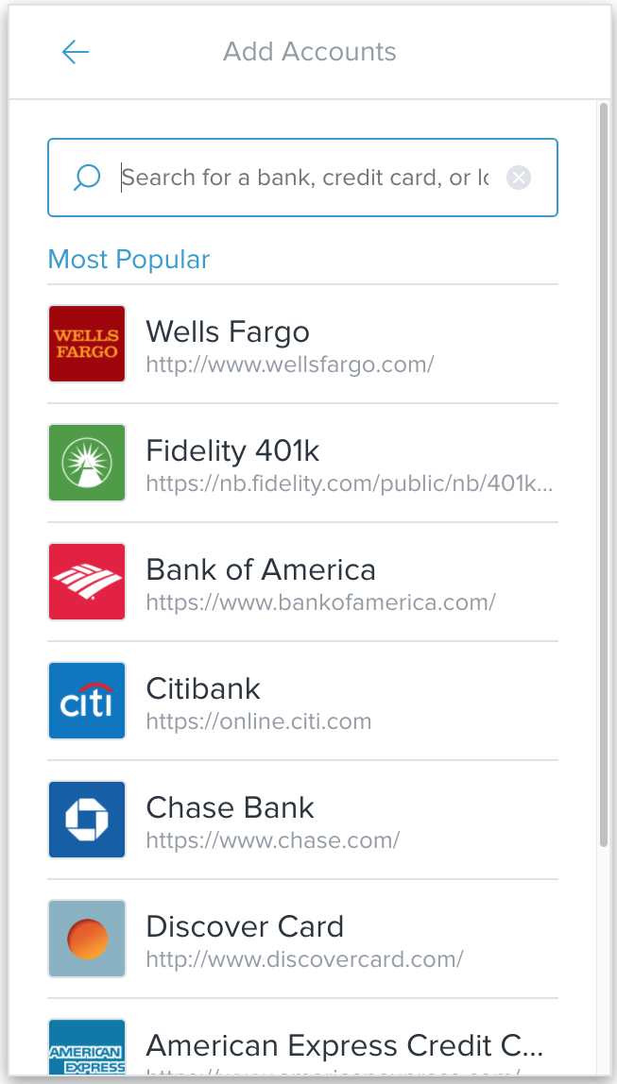 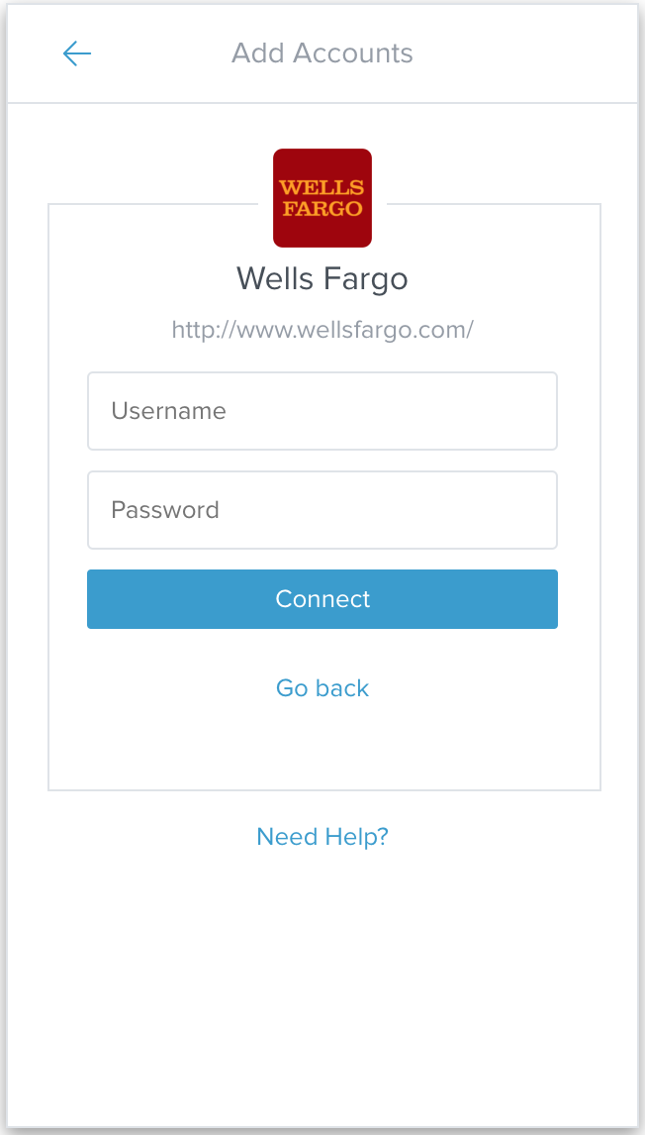

It’s possible that you may be asked to answer a question — like “Who was your mother’s first employer”? — or perform some other action for multi-factor authentication.

## Fixing connection errors

The software uses a multi-source strategy to provide the best possible connections to your financial institutions, but connection issues can still occur and are often solved with a few simple steps.

If there is a connection error on an account, you will see a yellow “!” over the account’s icon, along with a short message on the nature of the problem.

To resolve a connection error:

1. On the Accounts tab, tap on the account with the error.
2. Follow the troubleshooting steps indicated for your connection.
3. If you are unable to reconnect the account manually, tap “Need Help?” to request support.

## Manual account

Sometimes it’s just impossible for the app to automatically bring in important financial information. It might be that one of your financial institutions doesn’t support our software, or it might be that you paid off your home a decade ago, so there wouldn’t be an online account with any information about it.

In these kinds of situations, you should add a manual account. They’ll allow you to keep track of a lot of things with a lot of value: property like a home or car; cash that isn’t in a bank; a credit card that isn’t compatible with the app; a loan you’re paying back to a friend. These are all critical to your finances, so you should feel free to add as many as are necessary.

*ℹ️ — If you have a mortgage or loan that was used to buy property like a home or a car, you should add a manual account for the full value of that home, car, etc. That way, the app will keep track of the positive value of your assets and not just your debt.*

*Also, note that manual accounts must be updated using* *manual transactions**.*

To add a manual account:

1. Tap “Add an account” at the top of the Accounts tab.
2. Scroll down to the bottom of the next window and tap “Add a Manual Account.”
3. Give this account a name. It could be “Home,” “My other credit card,” or even “That secret gold I’ve got buried.”
4. Choose an account type. You can choose from the following:
   * Checking
   * Savings
   * Cash
   * Investment
   * Property
   * Credit Card
   * Mortgage
   * Loan
   * Line of Credit
5. Enter in the details. This could be a balance or value on property accounts, or you may need to enter an APR or APY on investments or mortgage accounts. Each type of account will require slightly different information. Make sure to fill out the details completely.
6. Tap “Save.”

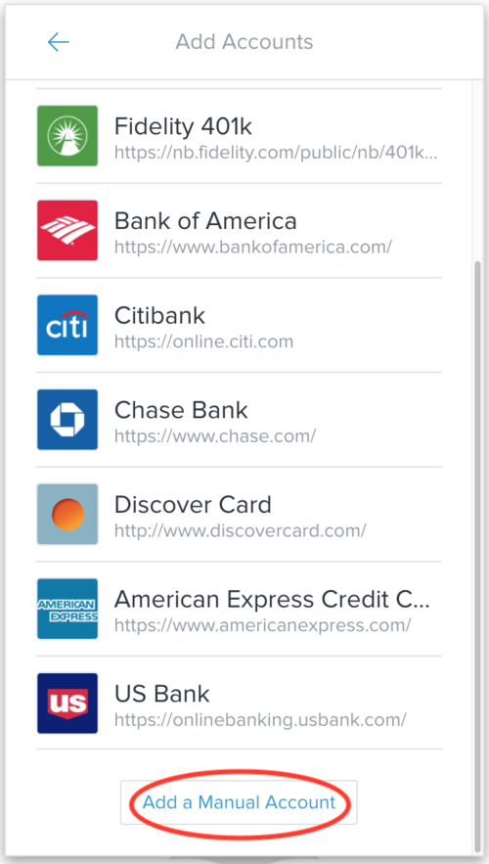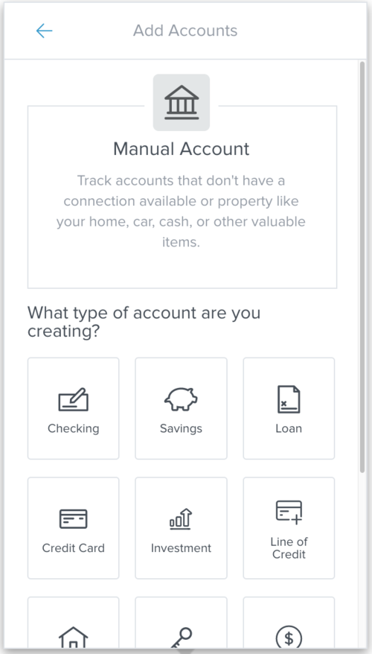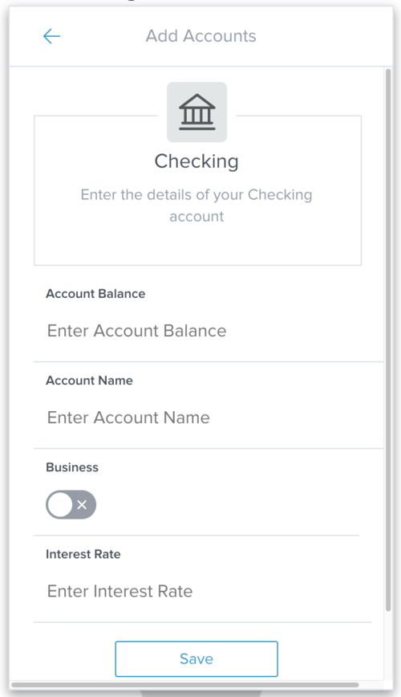

*ℹ️ — Getting the details you’ll need for step 5 may require pulling out a paper statement, making a call, or logging on to another online account — but it’s worth it. The app will be far more accurate — and you’ll rest far easier — knowing you’ve got all the information you need to take full advantage of this powerful software.*

## Account details

To see more information about your account:

* Tap on an account. This will open up its “Account Details” window.

This window shows not only your balance, but also a history of debits and credits over the last 12 months and a few recent transactions. By default, it shows activity information, indicated by the word “ACTIVITY” on the left side under your balance.

## Editing an account

You may need to change or update information in an account from time to time.

* On the “Account Details” window for your selected account, tap on “ACTIVITY” on the left to open a dropdown menu, then tap “DETAILS.”

You can edit the following information: account name, account type, interest rate, credit limit, original balance (debt accounts only), or account balance (manual accounts only).

* Tap on any field to edit it. Tapping on the “Account Type” field will bring up a list of account types. Tap on a type to select it. 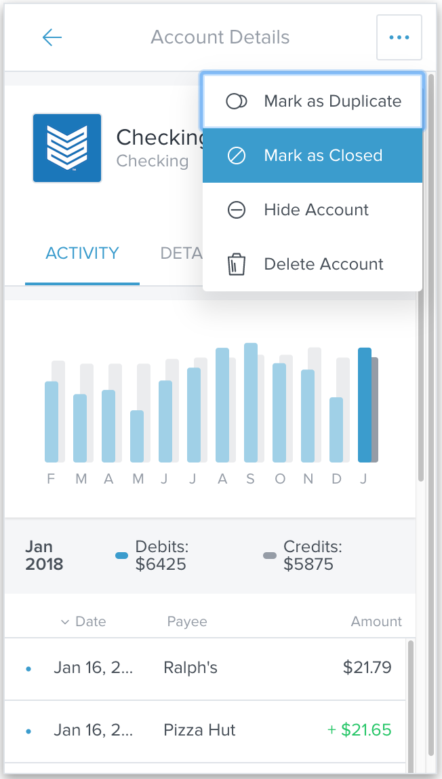

## Marking an account as closed

When you mark an account as closed, no more transaction data will be collected or stored for that account and the balance will be set to $0.00. This can’t be undone.

The past transaction history, however, will still be available.

To mark an account as closed:

1. On the “Account Details” window of the selected account, tap the “•••” button on the top right.
2. Select “Mark as Closed.” A window will appear asking if you really want to mark this account as closed.
3. Type “CLOSED” and then tap “Mark as Closed” to confirm. If you change your mind, tap “Cancel.”

Home accounts which were automatically linked by your financial institution can’t be marked as closed — but you can tell the software to ignore those accounts by hiding them.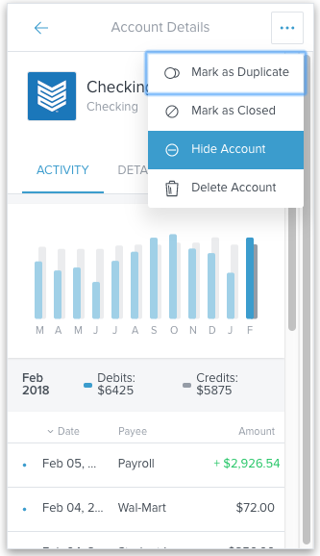

## Hiding an account

When you hide an account, the software will ignore all past and future data related to that account. The data will remain intact, however, and it’s easy to unhide if you want to use that data in the future.

You should hide an account if marking it as closed isn’t an option — as with home accounts — or if you’re not sure whether you’ll need that account’s data in the future.

To hide an account:

1. On the “Account Details” window of the selected account, tap the “•••” button on the top right.
2. Select “Hide Account.” A window will appear asking if you really want to hide the account.
3. Tap “Hide” to confirm. If you change your mind, tap “Cancel.”

Hidden accounts are displayed at the bottom of the list on the Accounts tab.

To unhide an account:

* On the “Account Details” window of the hidden account, tap “Unhide.”

## Merging an account

Duplicate accounts can appear when existing account connections are altered such as when a financial institution changes the way they name accounts in their system or when a lost or stolen credit card is replaced. When the account information is relayed to FIS under a different identity than in the past, it is created as a new account.

This type of duplication can be fixed by merging the accounts to ensure all data is retained.

*ℹ️ — Warning: Merging accounts can’t be undone.*

To merge duplicate accounts:

1. Determine which account is the original — it should have a longer transaction history.
2. On the “Account Details” window of that account, tap the “•••” button on the top right and select “Mark as Duplicate.”
3. Select the duplicate account from the list that appears.
4. A window will appear asking if you really want to merge the accounts. Merging accounts can’t be undone.
5. Tap “Merge” to complete the process.

## Managing account notifications

When something important happens in your financial life — like a large deposit, a low balance, or even a fee — it’s best for you to know about it as soon as possible. Our software can alert you via email, text message, or mobile push notification so you’ll stay in the loop wherever you are.

You’ll have to verify your email and mobile phone number to get these notifications. You can learn how to do that by reading the section on settings.

To manage alerts:

1. Tap the settings button on the top right of the screen. It looks like a small gear.
2. Tap “Notifications.”
3. Check or uncheck the alerts you want to receive using the slider buttons.
4. Tap “Edit” to change delivery methods and account settings.
5. Choose the method by which you want to be notified — email, text, or push notification — by checking the relevant boxes under “Delivery Methods.”
6. For notifications listed under “Accounts,” you can choose the specific accounts for which you want notifications. For each account, you can receive notifications by checking the box to the left, then set an amount at which the alert will trigger on the right.
   * For instance, you can set the “Large Deposit” alert for your checking account at $1,000 and the “Low Balance” alert for the same checking account at $200.

A more detailed explanation of notifications can be found in the Settings section.

# 

# Transactions

The Transactions tab provides a list of recent transactions from all of your accounts. If none of your accounts were automatically linked by your financial institution, you may be prompted to add an account when opening the Transactions tab.

For each transaction, you’ll see a date, an easy-to-understand payee, and an amount. Debits are in black and credits are in green.

When you start the software, it will immediately begin downloading your transactions. Some institutions take longer to download than others. The length of transaction history that can be imported on newly-linked accounts varies — though ninety days is common. FIS will save your transaction history moving forward.

## Categorizing your transactions

When transactions are pulled into the software, they will be automatically categorized. We encourage you to go through your transaction history to check that each transaction is categorized correctly. If you recategorize a transaction, the software will attempt to remember your preference the next time you post a similar transaction. Customizing your transactions will make things more accurate in the future.

There are 20 main categories and many more subcategories. This allows you to be as specific as possible when keeping track of your finances. You can even create new subcategories for things that don’t fit into one of the defaults.

To change a category: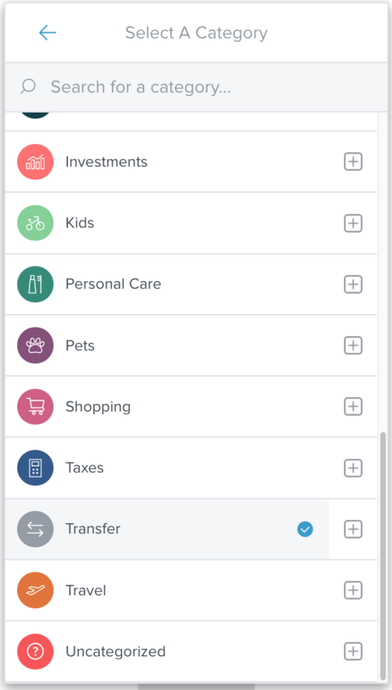

1. Tap on the transaction you want to recategorize. This will bring up the “Transaction Details” window.
2. Tap on the “Category” field. This will bring up the “Select A Category” window.
3. Tap on a main category to select it, or tap one of the “⊞” buttons on the right to bring up related subcategories. A blue checkmark should appear on the right of your selected category.
4. If you can’t find the category you’re looking for, use the search bar near the top of the screen.

## Uncategorized transactions

If Personal Finance isn’t reasonably certain of which category a transaction belongs to, it may be left uncategorized. When you open your transactions list, you will be prompted to assign a category to these transactions.

* Select “No Thanks” to ignore the prompt. It will appear again the next time you log in, if you still have uncategorized transactions.
* Select “Categorize” to view and categorize the transactions.

## Editing, splitting, tagging, flagging, and more

You can do a lot more than just change a transaction’s category — you can customize the payee description, edit the date, add tags for custom searching, add a memo to remind yourself of details about the purchase, flag a transaction, split a transaction between multiple categories, or exclude a transaction from your spending reports.

## Splitting transactions

Some transactions encompass multiple categories in a single purchase. This is particularly common at big box stores like Costco or Walmart where you might buy groceries, home supplies, and a DVD all in one purchase. You can split a transaction between as many categories as needed to accurately account for your spending.

To split a transaction:

1. Tap on the transaction you want to split. This will open the “Transaction Details” window.
2. Tap the “•••” button on the top right to view additional options.
3. Tap on “Split.”
4. Enter the amount and category for each part of the split. Add more splits by tapping “Add Another Split,” and delete splits with the trash can icon to the right.
5. Tap “Save Split” to confirm your changes.

To delete a split:

1. Tap on any split transaction to view the parts of the split. Then tap on a split to bring up the “Transaction Details” window for that split.
2. Tap on the trashcan. A warning message will appear asking if you want to delete this and all other splits.
3. Tap “Delete” to confirm.

## Adding a manual transaction

If you’re using a manual account to track cash spending or an account that doesn’t support Personal Finance software, you may wish to add manual transactions to keep track of changes that can’t be automatically imported.

To add a manual transaction:

1. Tap the “+” icon on top right.
2. Enter the details of your transaction — amount, payee, date, category, account, type (i.e., credit or debit), and a memo if necessary. Tap the slider to choose credit or debit.
3. Tap “Save.”

*ℹ️ — Manual transactions can only be added to manual accounts. When selecting an account, you will be able to choose only from your manually-created accounts.*

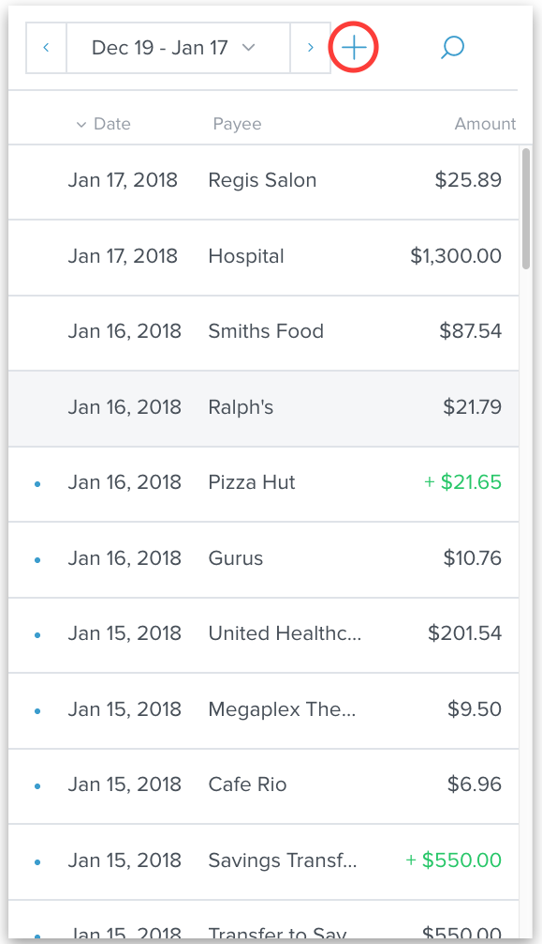 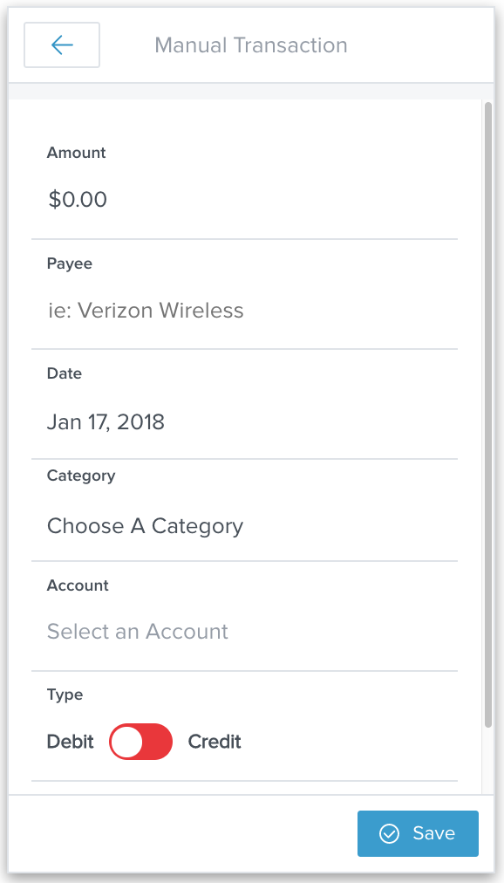

## Pending transactions

If an incoming transaction is marked as pending, it will be shown at the top of the transactions list in italics. Pending transactions are editable, but changes will not be saved when the transaction moves from pending to posted.

## Deleting and excluding transactions

Only pending and manual transactions can be deleted.

Occasionally, a transaction may appear twice — once as pending and once as posted. You can delete the pending transaction if it does not automatically reconcile with the posted transaction.

To delete a pending or manual transaction:

1. Tap the transaction to open its “Transaction Details” window.
2. Tap the “•••” button.
3. Tap “Delete.”
4. Tap “Delete” to confirm.

If you’d rather not delete a transaction, you can exclude it. This means the transactional data will be saved, but the software won’t factor it into your financial reports. The transaction will still be visible on the Transactions tab, but it will be marked as “Excluded” and the amount will not be factored into any calculations. It can be re-included later if you change your mind.

To exclude a transaction:

1. Tap on a transaction to open its “Transaction Details” window.
2. Tap the “•••” button on the top right to view additional options.
3. Tap “Exclude.”
4. Tap “Exclude” to confirm.

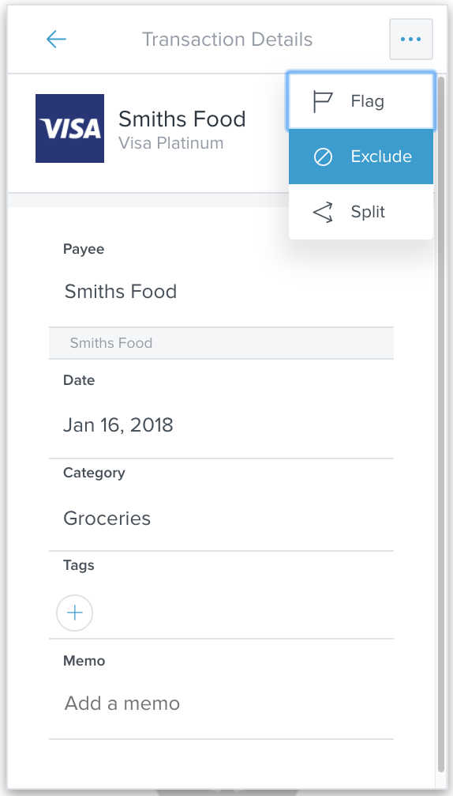 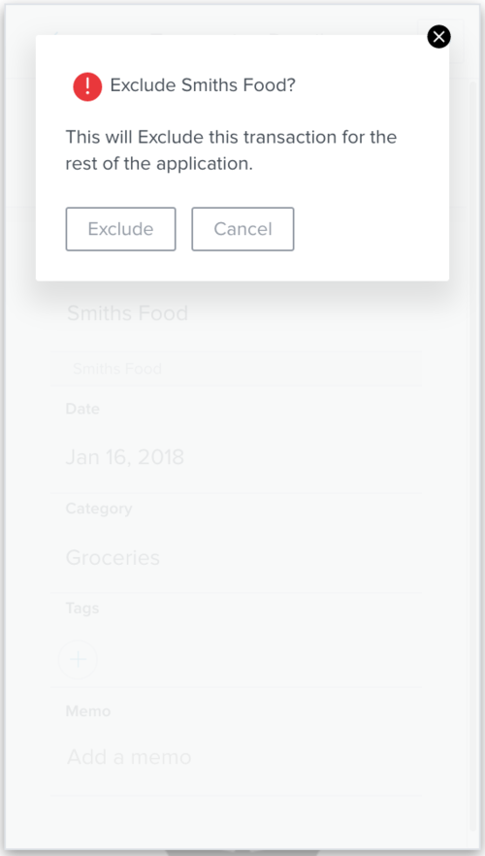

## Search, sort, and filter transactions

By default, you’ll see transactions from all accounts over the previous 30 days, listed chronologically. You can filter these transactions by account or date range, and you can sort your transactions by date, payee, or amount.

* Tap on the column headings to sort the list.
* You can also search by tapping on the magnifying glass and entering your search term in the bar that appears.
* Use the arrows near the date to move backward or forward one month.
* Tap the date to select from a list of preset options.
* Tap the date within the preset options menu to open a calendar and select a custom date range.

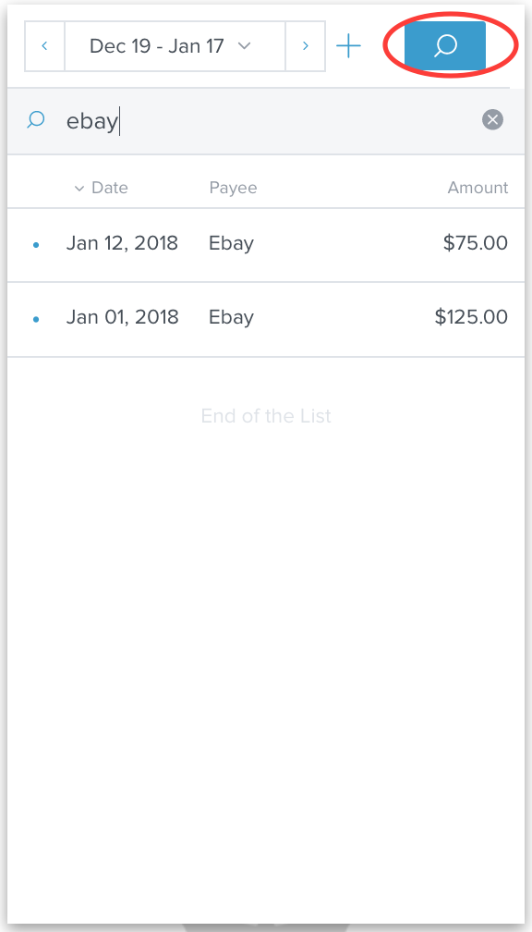

# 

# Spending

The Spending tab shows you where your money is going — sorted by category — so you can better understand your spending habits and stay on track.

*ℹ️ — If your spending in a particular category is below three percent of your overall spending, it will be grouped in “Other” along with all other low-spending categories.*

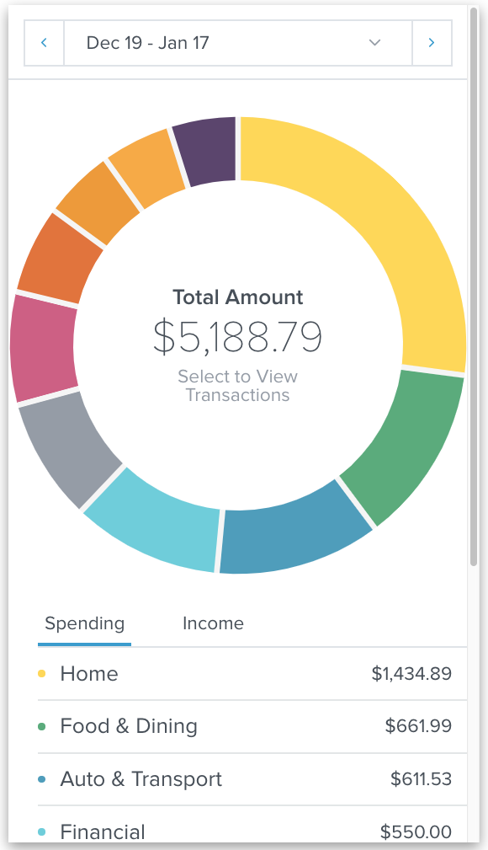 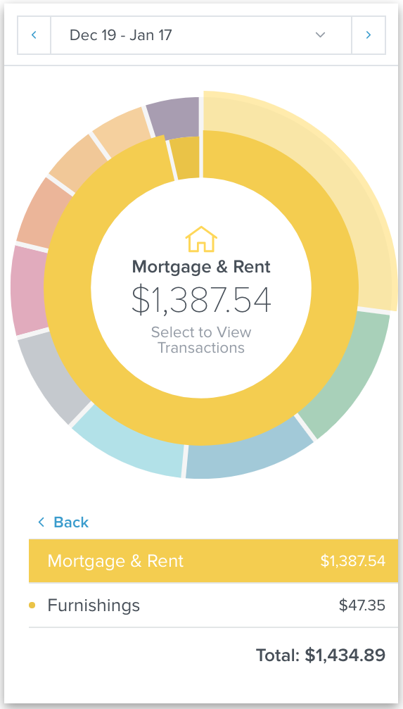

* Tap on a section of the wheel to see how much you spent in that category.
* Tap on a category twice to bring up a second wheel showing subcategories.
* Tap on any subcategory — or on the center of the spending wheel — to see transactions associated with a selected subcategory. From this window, you can also edit transaction details just like in the Transactions tab.
* To return to the main spending wheel, tap on the blue arrow on the top left.
* Tap "Income" to view your income within the selected date range. Tap "Spending" to return to the spending wheel.

You have multiple options for adjusting the date range:

* Use the arrows near the date to move backward or forward one month.
* Tap the date to select from a list of preset options.
* Tap the date within the preset options menu to open a calendar and select a custom date range.

To view your income:

* Tap “Income” on the bottom left.
* As with spending, you can tap on an income category to view your income by subcategory and tap again to view income transactions.

# Budgets

Budgets can help you set realistic monthly spending limits and avoid exceeding those limits. The Budgets tab draws your eye to the areas that need your attention the most — big bubbles represent a larger portion of your monthly budget, and red bubbles have exceeded their monthly allowance.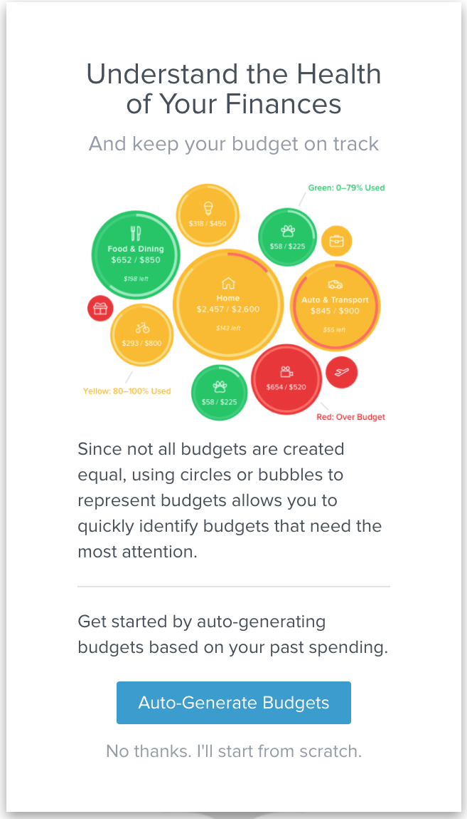

## Auto-generating budgets

When you first use Budgets, you have the option to either:

* Tap “Auto-Generate Budgets” to let the software budget for you, or;
* Tap “No thanks. I’ll start from scratch” to create your own budgets.

We encourage you to use the auto-generate budgets feature; it will create a budget based on your average spending in each category over the last two months for which there is complete data.

This calculation will be more helpful if you have first added all your accounts and have reviewed your transaction history for accuracy. Still, you should review your generated budget and adjust them if necessary. The variable nature of initial data gathering can impact how your budgets are generated.

You can decide which categories you do and do not want included. If a category was added during auto-generation that you do not want in your budget, you can delete it.

## Starting from scratch

If you choose to start from scratch, the software will present a list of categories that can be used for a budget. Those not yet in use will be grayed out.

1. Tap on the “+” icon on the right to create a budget for that category.
2. To give the budget a dollar amount, you’ll need to use bubble budgets.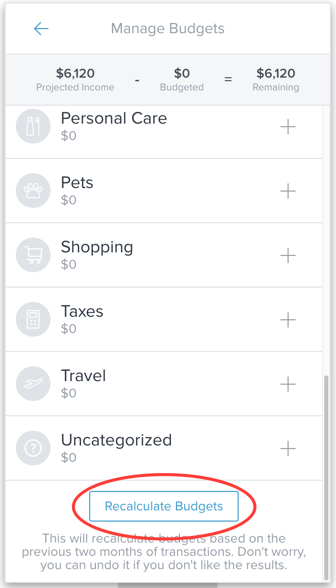

## Recalculating budgets

You can recalculate your budgets at any time.

1. Tap the “+” icon on the top right of the Budgets screen.
2. Scroll to the bottom of the screen.
3. Tap “Recalculate Budgets.”

*ℹ️ — Auto-generated budgets are based on the last two months for which there are complete data; this ties your budgeting experience to your actual spending.*

## Using bubble budgets

Once you’ve set up at least one budget, you’ll see bubble budgets by default. Bubble budgets allow you to see both the health and the impact of your budget categories by drawing your attention toward the areas that need it most.

The color of a bubble budget indicates whether you are on track, nearing your budget limit, or over budget.

* Green: below 80%
* Yellow: between 80-100%
* Red: over 100%

The size of your bubble represents the budget amount relative to your overall budget. The larger the bubble, the more of your overall budget that category consumes.

You can also easily view all transactions related to a particular budget to see exactly where you spent money.

To view budget transactions:

1. Tap on any budget to bring up the budget details window. 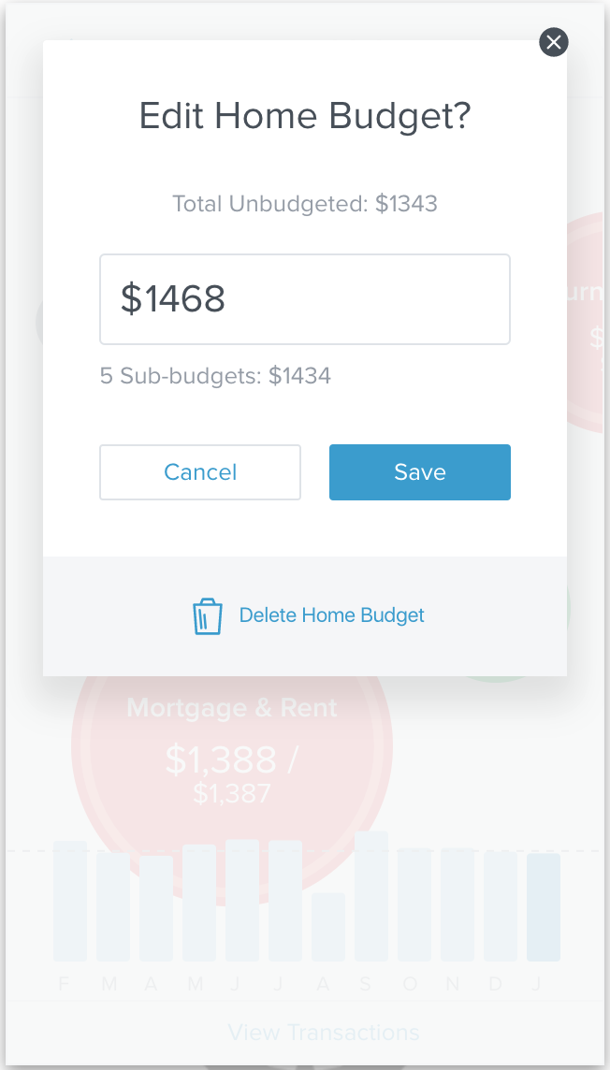
2. The current month will be selected by default. Tap a previous month on the bar graph below the bubble budget to select that month.
3. Tap the bubble budget or “View Transactions” to see all transactions related to that budget category. They can be edited exactly as in in the Transactions tab.

## Editing budgets

Even after using the auto-generate feature, you may want to adjust a budget’s amount.

* Tap on a bubble to display the budget details window.

Here, you can edit or delete the selected budget, view spending trends in the associated category, and add sub-budgets.

To edit the budget amount:

1. Tap the pencil icon attached to your selected bubble budget.
2. Enter in a new amount.
3. Tap “Save,” or tap “Cancel” if you change your mind.

To create a sub-budget:

1. Tap the “+” button attached to your selected budget.
2. Select a subcategory for your sub-budget.
3. Tap “Add a Subcategory” if you can’t find the one you’re looking for and you’d like to create a new one.

The sub-budget will automatically be created. You’ll also be taken to the budget details window for that subcategory.

*ℹ️ — If you make a sub-budget larger than its parent budget, the parent budget will increase to compensate. Deleting or reducing a sub-budget will not affect the parent budget.*

To delete a budget or sub-budget:

1. Tap on a budget to open its details window.
2. Tap on the pencil icon.
3. Tap “Delete [budget name].”
4. Tap “Delete” again to confirm.

## Projected income

A projected income for the next month is automatically calculated for you based on your transaction history; you can, however, edit this number manually. This projected income will help you make smart budget decisions which are in line with your income.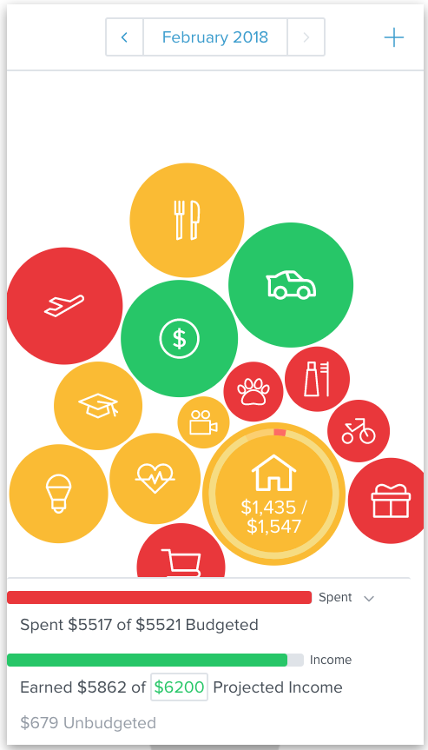

To edit projected income:

1. Tap on the panel at the bottom of the budgets tab. You may need to scroll down to see it.
2. Tap the green projected income amount.
3. Enter a new amount.
4. Tap “Save.”

## Adding and deleting budgets

If you need to add or delete a lot of budgets quickly, it’s best to use the “Manage Budgets” feature. Here you can view all your budgets, delete them with just a couple clicks, and add new budgets for categories that aren’t yet in use.

To add a budget category:

1. Tap the “+” button on the top right of the main Budgets screen to open the “Manage Budgets” window.
2. Scroll to the bottom of the window to see categories labeled “Not in Use.”
3. Tap the “+” button to the right of the budget category you’d like to add. The new budget will appear.
4. To give the budget a dollar amount, follow the steps above for editing a budget amount.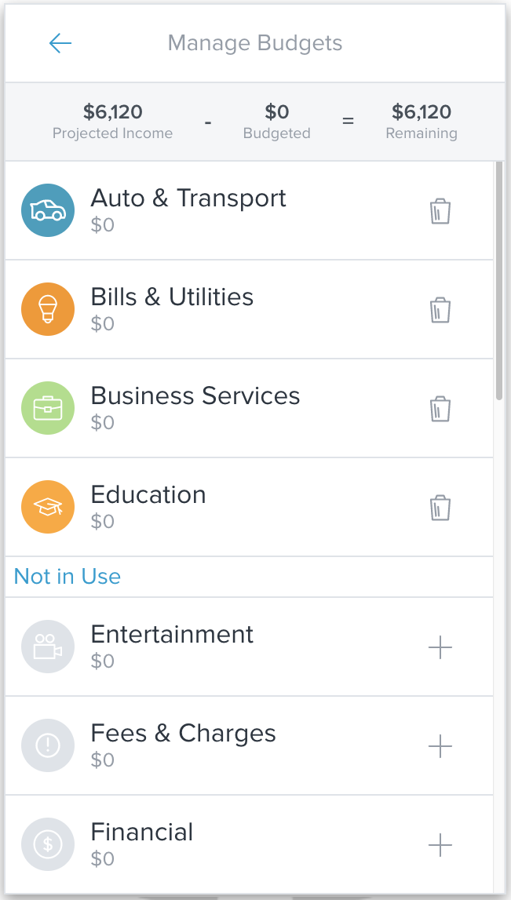

To delete a budget category:

1. Tap the “+” button on the top right of the main Budgets screen to open the “Manage Budgets” window.
2. Tap the trash can to the right of the budget you want to delete.
3. Tap “Delete” to confirm.

# Goals

Whether it’s saving for retirement, paying off a car loan, or just putting some money away for emergencies, we all have financial goals that require long-term planning. The Goals tab helps you make those plans and allows you to visualize them on a simple timeline.

Each goal you create will be connected to one of the accounts you’ve added, and they will be automatically updated as you put money into a retirement account or pay off a debt.

Goals appear on the timeline as colorful circles. As you scroll to a savings or retirement goal, you’ll see the amount you’ve put aside for that goal as well as the total amount you hope to achieve.

The first time you view the Goals tab, you’ll see a welcome screen.

* Tap “Get Started.”

This will bring up the tab’s main screen. Here, you’ll see the timeline with the future up at the top of the screen. On the left you’ll see a slider, used to navigate back and forth on the timeline. You’ll see “Total Monthly Contribution” on the top left and buttons to add and manage goals on the right.

You should set up a few goals before doing anything else. To set up a goal:

1. Tap the “+” button at the top right.
2. Choose a goal type: savings, debt payoff, or retirement.

Each type of goal is a little different and requires slightly different information. It’s often a good idea to set up a savings goal first.

## Savings goals

To add a savings goal:

1. Tap the “+” button at the top right.
2. Tap the “Savings” goal type.
3. Select a more specific type of savings goal. You can choose from: emergency fund, automobile, college, home, recreational, vacation, electronic, or other.
4. Edit the details for the goal: give it a name and set an amount you would like to save for your goal.
5. Tap the “Select an Account” field. A window will appear listing all your non-checking, non-debt accounts.
6. Tap the account you’d like to use for this goal.
7. Tap “Save.”

This goal will now appear on the main page of Goals — a green circle right above the date when the savings goal is expected to be achieved.

* Tap the green savings goal on the timeline to bring up details about the goal and make changes.

## Debt payoff goals

If you’ve already connected a debt account to the software, then Goals will automatically pull in the information it needs to create a debt goal — including balance, APR, and minimum payments. Goals will use your minimum payment information to automatically calculate the date the debt will be repaid, but you can add more to your monthly contribution to pay things off sooner.

1. Tap the “+” button on the top right of the main Goals window.
2. Tap the “Debt Payoff” goal type. This will bring up a window that lists all of your debt accounts.
3. Check all the accounts you wish to track.
4. Tap save.

Each debt account you selected will appear on the timeline as a blue circle above the date when they are expected to be paid off.

* Tap the blue debt on the timeline to bring up details about the goal and make changes.

## Retirement goal

To add a retirement goal:

1. Tap the “+” button on the top right of the main Goals window.
2. Chose the “Retirement” goal type.
3. If you have already entered in personal information on the Settings section, your birthday will automatically be imported. Otherwise, you can select the date of your birth by tapping the dropdown menu.
4. Choose the age at which you would like to retire. The default is 65.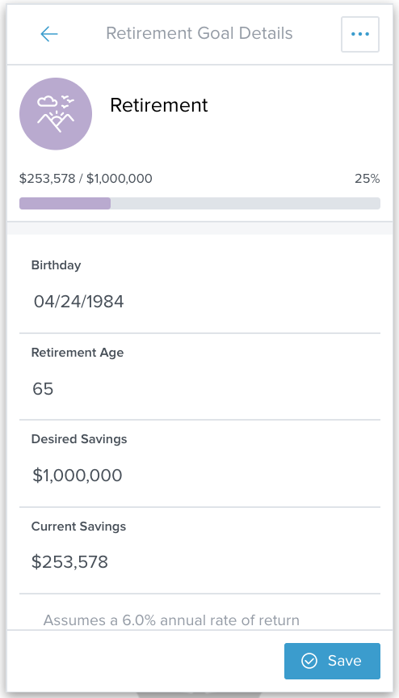
5. Enter the amount of money you’d like to have when you retire.
6. Tap “Current Savings.” This will open a window from which you can choose a retirement account.
7. Check one or more retirement accounts. The total balance of selected accounts will be listed as your current savings. Tap “Add it Here” if you need to connect another account to the software.
8. Tap “Save.”
9. Tap “Save” on the next window as well.

This goal will appear on the timeline as a purple circle above the date you will reach your chosen retirement age. As you scroll to it, you’ll see your current retirement savings and your desired savings side-by-side.

If you aren’t projected to achieve your desired retirement savings by your selected age — based on a 6 percent average rate of return — a blue “i” symbol will appear.

* Tap your retirement goal to bring up details about the goal and make changes.
* Tap this circle when the blue “i” appears to see what your projected retirement savings will be by your retirement age and how much less that is than your desired savings.

## Managing goal contributions and priorities

Now that you’ve created some goals, you should determine what kind of monthly contribution makes sense for each goal. This will affect when each goal will be achieved.

* Tap on the manage goals button on the top right. It looks like a bulleted list.

Here, you can adjust the size of your contribution to each goal type and determine the priority of goals within a specific type.

A *contribution* is the amount of money that you plan to allocate each month to an overall goal type. The *priority* is the order in which that contribution will be applied to each goal within a particular type. 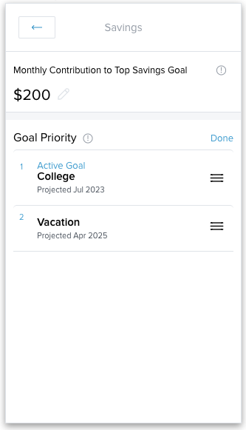

Your monthly contribution will be applied to whatever goal has the highest priority. When that goal is achieved, the contribution will be applied to the goal with the second-highest priority and so on.

To adjust your contribution and priority for savings goals:

1. Tap the manage goals button.
2. Tap “Savings.”
3. Tap the pencil icon on the top left and enter a monthly contribution.
4. Tap “Reorder” on the right to adjust the priority of multiple goals.
5. Tap and drag the goals into the order you prefer.
6. Tap “Done.”

Debt goals are managed differently. Your contribution is an amount *in addition* to your minimum payments for each debt.

To adjust your contribution and priority for debt goals:

1. Tap the manage goals button.
2. On “Debt Payoff.”
3. Tap the pencil icon on the top left and enter a monthly contribution.
4. Tap the dropdown menu to the right to reorder debt priorities. This will default to “Fastest Payoff First.” You can also choose “Highest Interest First,” “Lowest Balance First,” and “Highest Balance First.”

To adjust your contribution to your retirement goal:

1. Tap the manage goals button.
2. Tap “Retirement.”
3. Tap the pencil icon on the top left and enter a monthly contribution.

You will have only one retirement goal; hence you won’t need to determine a priority.

# Net Worth

The Net Worth tab tracks the sum of all your assets and liabilities. Property Accounts can be added manually on the Accounts tab to account for key assets, such as the value of your home or vehicle. See “manual accounts” for more details on adding manual accounts.

You can choose to view the past 6, 9, or 12 months of net worth history. New users may not have sufficient transactions to receive accurate historical net worth, but the software will continue to save transaction data moving forward in order to provide better historical insights.

The dots on the graph represent your net worth each month. The lines represent the change in your net worth from month to month.

1. Tap on a circle to see the details of how your net worth increased or decreased.
2. Tap on the same circle again to bring up a list of gains and losses.

A window will appear showing the gains and losses within each account during that month.

* Gains: When an asset increases in value or a liability decreases in value, your net worth will go up. For example, putting money in savings or making a car payment.
* Losses: When an asset decreases in value or a liability increases in value, your net worth will go down. For example, pulling money out of savings or spending more on a credit card than you can immediately pay off.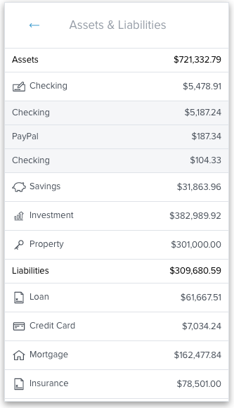

You can also use Net Worth to keep track of your total assets and liabilities displayed as a list of by account type.

To view your assets and liabilities:

1. Tap “Assets & Liabilities” at the top to view these figures.
2. Tap on an account type to view individual accounts.

A window will appear showing your assets and liabilities within each account during that month.

* *Assets*: Positive values that count toward your net worth, such as money in checking accounts, the value of your home, etc.
* *Liabilities*: Negative values that count against your net worth, such as credit card debt, loans, or a mortgage.

# Cash Flow

The Cash Flow tab helps you see the impact of recurring payments and deposits and plan for the next month. You can easily add recurring events, as well as one-time or annual payments — like property tax. It also shows you how much cash you currently have on hand.

When first using Cash Flow, you’ll see a few welcome screens that explain how the tab works.

* Tap “Next” until you see the “Add a Cash Event” window.

The software searches through your spending and deposit history to find recurring events, then displays them for you here. These are called *cash events.*

To add a cash event from the initial screen:

1. Tap the green “✓” to accept a suggested event or the red “X” to reject it.
2. Select the correct frequency for that event, e.g., monthly, every other week, every 3rd Sunday, etc.
3. When you’re done adding events, tap the back button on the top left.

You’ll now see your currently-available cash — based on your asset accounts — plus a list of upcoming payments and their dates.

Cash events that have already been paid will have a blue checkmark to the left. Those that are upcoming will have a small empty circle. Those that appear to be past due will have a red exclamation point.

## Filtering by account

You can filter which cash events are displayed on the main Cash Flow window based on the associated account.

1. Tap the “Accounts” drop down menu on the top left. It will tell you the number of accounts currently being displayed, e.g., “3 Account(s).”
2. Check the accounts you want to see in Cash Flow, and uncheck those you don’t.

## Editing cash events

Cash events can be income or expenses, one-time or recurring — but they will always include a few important details that you can edit.

1. Tap on a cash event.
2. Tap the “•••” button on the right.
3. Tap “Edit.”
4. You can choose to edit the following fields by tapping on them:

* *Payee*: The name of the cash event, for example, “Paycheck” or “Mortgage Payment.”
* *Average amount*: The average amount of the recurring transaction.
* *Type*: Specifies whether the event is income or an expense.
* *Account*: Specifies the account in which the event occurs.
* *Frequency*: The date and repeating schedule for the event.
* *Category*: An optional spending category for the event.

## Adding a cash event

You can add cash events directly from a list of suggestions. You can also create your own from a list of past transactions, or in anticipation of an upcoming transaction. You can even create a cash event entirely from scratch for transactions that occur outside the software.

To add a cash event:

1. Tap “Add Event” on the top right to bring up a list of suggested cash events.
2. Tap the green “✓” to accept a suggested event or the red “X” to reject it.
3. Select the correct frequency for that event, e.g., monthly, every other week, every 3rd Sunday, etc.

To create your own cash event:

1. Tap “Add Event.”
2. Scroll to the bottom of the list of suggestions and tap “Create Your Own.”
3. Select either “Based on a Past Transaction” or “Start from Scratch.”
4. If you chose to use a past transaction, you’ll see a list of transactions to choose from.
5. Find the appropriate transaction and tap it.
6. Select the correct frequency for that event, e.g., monthly, every other week, every 3rd Sunday, etc.
7. Tap “Save.”
8. If you selected “Start from Scratch” in **Step 3**, you’ll see a window for editing the details of a cash event.
9. Enter a payee, average amount, type, associated account, frequency, and optional category.
10. Tap “Save.”

## Marking as paid

You may want to mark a cash event as paid if you pay it off early, or if it’s an event you created from scratch. When you mark an event as paid, you can optionally link it to a specific transaction in one of your accounts.

To mark an event as paid:

1. Tap on the cash event.
2. Tap “Mark as Paid.”
3. To link this cash event to a transaction, tap “Link to Transaction.” Otherwise, tap “No Thanks.”

## Deleting a Cash Event

To delete an event:

1. Tap the event’s name on the list,
2. Tap the “•••” button.
3. Tap “Delete.”

You have the option to delete this and all future events, the entire series including past events, or just that single event.

# SettingsSettingfs button.jpg

Under Settings, you can update your profile information, set up and manage connected mobile devices, and manage all the alerts you learned about under Accounts.

* Tap the settings button on the top right of the app. It looks like a small gear. This will bring up the settings window.

## Profile

Within the Profile tab, you can enter your name, email address, mobile phone number, postal code, credit score, birthday, and gender.

This information is sometimes used by financial institutions to provide products and services that are best suited to you.

Here you can also verify your email address and mobile phone number so notifications will function properly. Emails or mobile notifications with sensitive financial information will only be sent to verified addresses and numbers. Other messages may be sent to unverified emails and addresses.

To verify your email address:

1. Enter your email address in the appropriate field.
2. Tap “Save” at the bottom of the screen. The word “Verify” will now appear next to your email.
3. Tap “Verify.”
4. Tap “Send Verification Email.”
5. Access your email account and follow the instructions in the verification email. 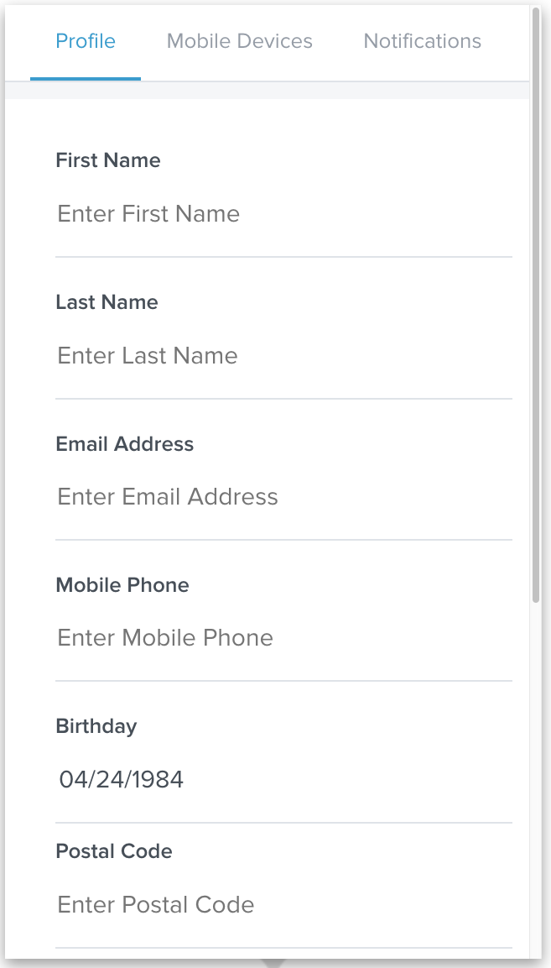

To verify a mobile phone number:

1. Enter in your mobile phone number in the appropriate field.
2. Tap “Save” at the bottom of the screen. The word “Verify” will now appear next to your mobile phone number.
3. Tap “Verify.”
4. Tap “Send Verification Token.” You will be sent a text message with a verification code.
5. Enter in the code that was sent to you.

## Mobile devices

To register a mobile device:

1. Download the appropriate mobile app.
2. Tap on the settings button.
3. Tap on the “Mobile Devices” tab.
4. Tap “Generate Access Code.”
5. Enter temporary access code into the mobile app.

Once registered, your mobile device will stay registered with your account; there is no need to log in or out of the app. An optional app lock can be enabled in the app’s settings for data privacy.

## Notifications

Notifications can help you stay on track by keeping them notified of important events in their finances. You must verify your email address and/or mobile phone number before some types of notifications will be sent.

You can choose to be notified when one or all of the following occur:

* A large deposit over $500
* A large expense over $100
* An account balance falls below $100
* You get charged a fee
* You have a debt payment coming up
* You exceed a budget

To set up notifications:

1. Tap the settings button on the top right of the screen. It looks like a small gear.
2. Tap “Notifications.”
3. Check or uncheck the notifications you want to receive using the slider buttons.
4. Tap “Edit” to change delivery methods and account settings.
5. Choose the method by which you want to be notified — either email, text, or push notification — by checking the relevant boxes under “Delivery Methods.”
6. For notifications listed under “Accounts,” you can choose the specific accounts for which you want notifications. For each account, you can receive notifications by checking the box to the left, then set an amount at which the alert will trigger on the right.
   * For instance, you can set the “Large Deposit” alert for your checking account at $1,000 and the “Low Balance” alert for the same checking account at $200.

You can select not only which notifications you want, but on which specific accounts and even what amount should trigger an alert.

* Tap the checkbox on the left of an account listed under the relevant notification to enable or disable that alert for that account.

Notifications will be delivered nightly after account information has been updated. Budget alerts will be grouped into one email. Other alerts will appear in separate emails.

Alerts that contain sensitive financial information will only be sent after you’ve verified your email address and/or mobile phone number. General emails may be sent to unverified email addresses.

# 

# 